The dog ate my homework! (Class Y)
Spin the black / orange spinner:

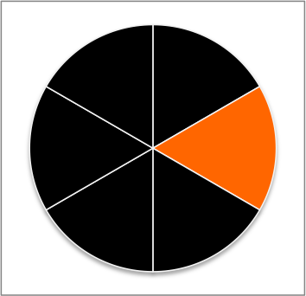

Is the student telling the truth?

- black means the student is telling the truth – take a black cube
- orange means the student is lying – take an orange cube
Lying and accused

Whatever the outcome of the first spin, this time spin the green/white spinner also:

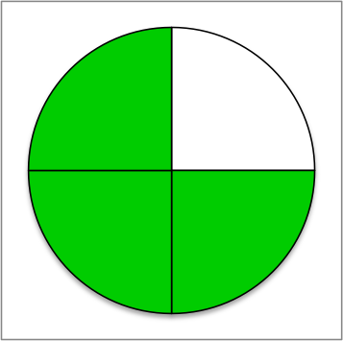
Truthful and not accused
Truthful but accused

Does Mr D accuse the student?
- green means Mr D believes them, and does not accuse them – take a green cube and stick it onto the black or orange one
Lying and not accused
- white means he thinks they are lying, and he accuses them – take a white cube and stick it onto the black or orange one

