The dog ate my homework!
Spin the truthful / lying spinner:

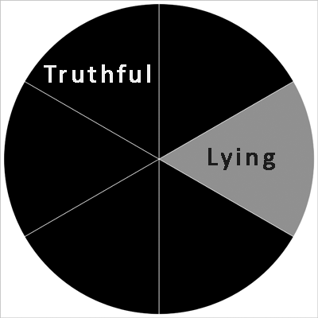

Is the student telling the truth?

- black means the student is telling the truth – take a black cube
- grey means the student is lying – take an orange cube
Lying and accused

If the student was lying, Mr D will accuse them. Take a white cube, and stick it onto the orange one.

If the student was NOT lying, then spin the not accused / accused spinner:

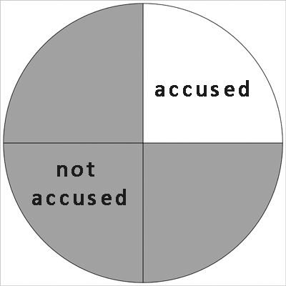
Truthful and not accused
Truthful but accused

Does Mr D accuse the student?
- here grey means Mr D believes them, and does not accuse them – take a green cube and stick it onto the black one
- white means he thinks they are lying, and he accuses them – take a white cube and stick it onto the black one

