Which team will win? (Season 2)
Spin the spinner once:

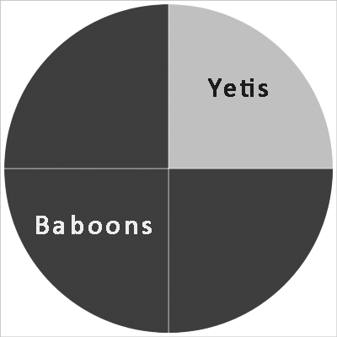

Which team will score?

- if the Baboons score, spin again for the second goal
- If the Yetis score, spin the spinner below for the second goal

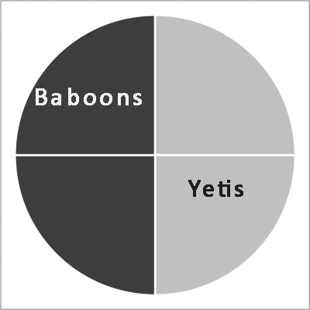

Exactly two goals are scored in each match. Record your results for a 16 match season in a table and then tally the results.

 | 1st goal | 2nd goal | Result
1 | Y | B | YB draw
2 | B | Y | BY draw
3 | Y | Y | YY win
4 | B | B | BB win
5 | …

YY wins | /// | 3
BB wins | //// / | 6
YB draws | //// | 5
BY draws | // | 2
Total |  | 16

