Which team will win?
Spin the spinner twice:

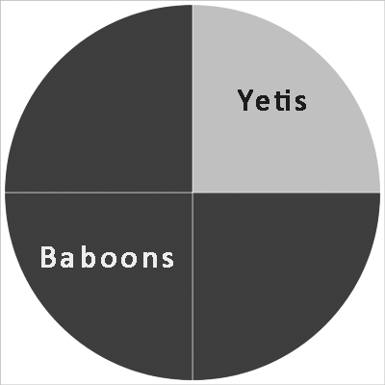

Which team will score?

- darker grey means the Baboons score a goal
- lighter grey means the Yetis score a goal

Exactly two goals are scored in each match. Record your results for a 16 match season in a table and then tally the results:

 | 1st goal | 2nd goal | Result
1 | Y | B | YB draw
2 | B | Y | BY draw
3 | Y | Y | YY win
4 | B | B | BB win
5 | …

YY wins | /// | 3
BB wins | //// / | 6
YB draws | //// | 5
BY draws | // | 2
Total |  | 16

- How many times did the Yetis win (YY)?
- How many times did the Baboons win (BB)?
- How many times did the Yetis score first, but the Baboons then equalised (YB)?
- How many times did the Baboons score first, but the Yetis then equalised (BY)?
- Do any of your results surprise you at all? Why (not)?
- The Baboons have more chances to score than the Yetis. What does this tell you about the teams?

